**Data Manipulation and Reporting with Power BI**

**Zomato Global Analysis**

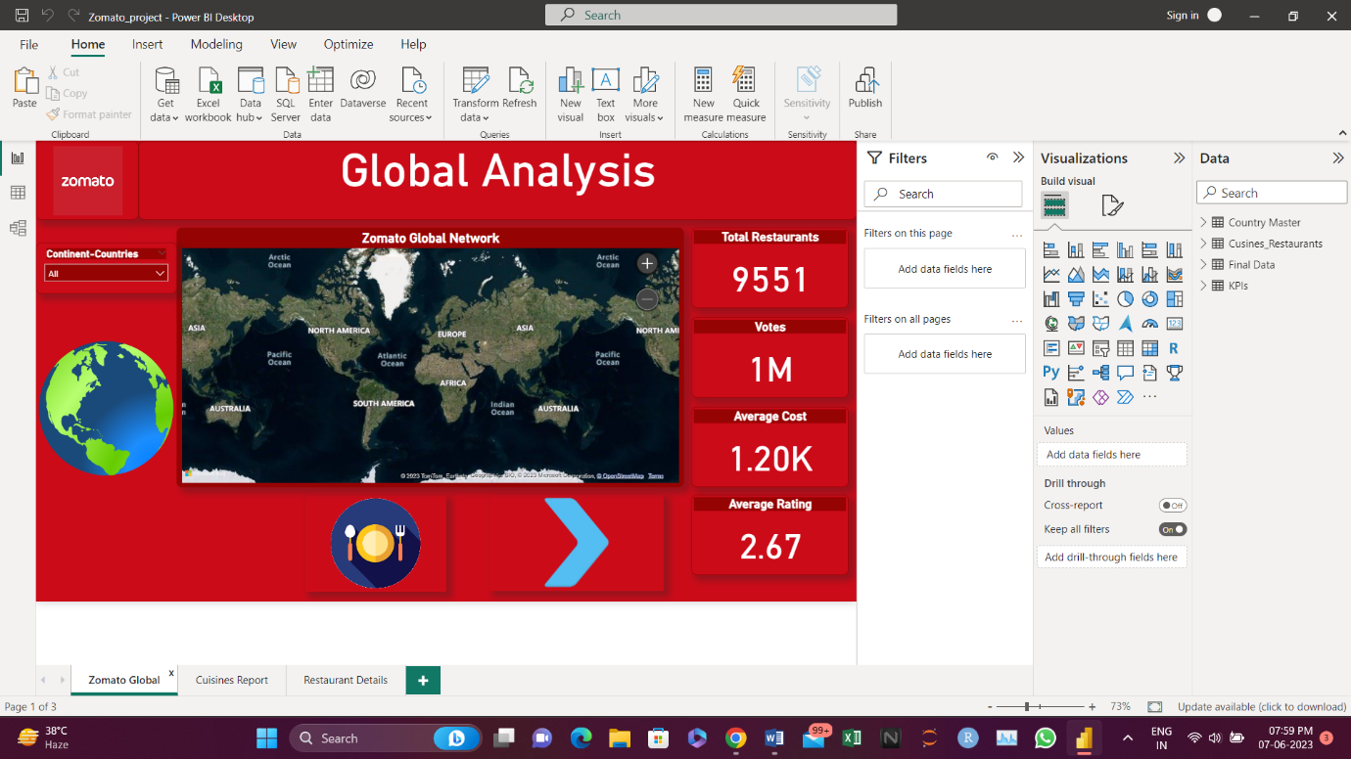Zomato Global Report:

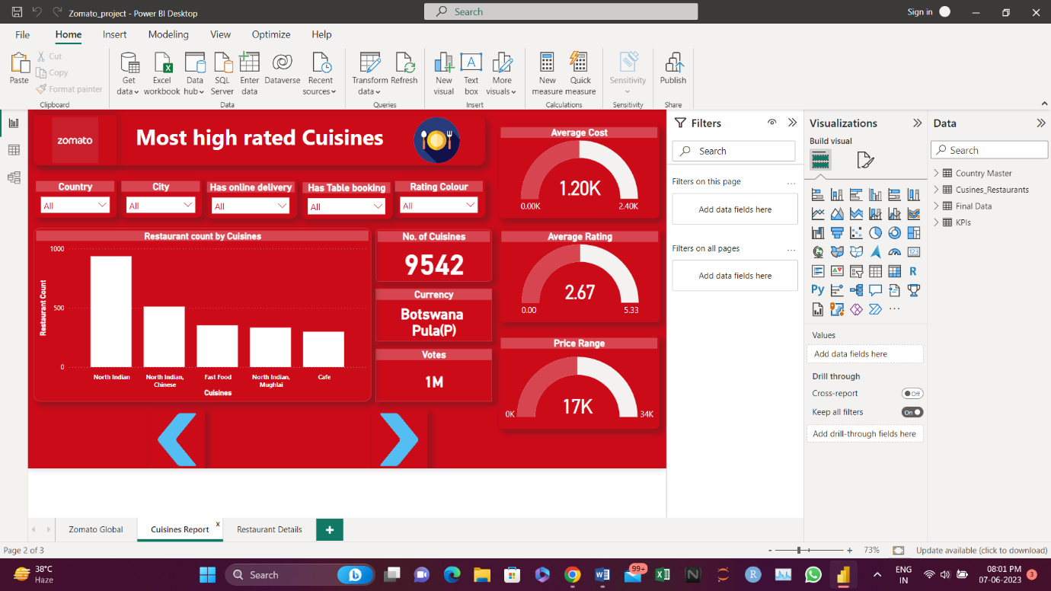Cuisines Report:

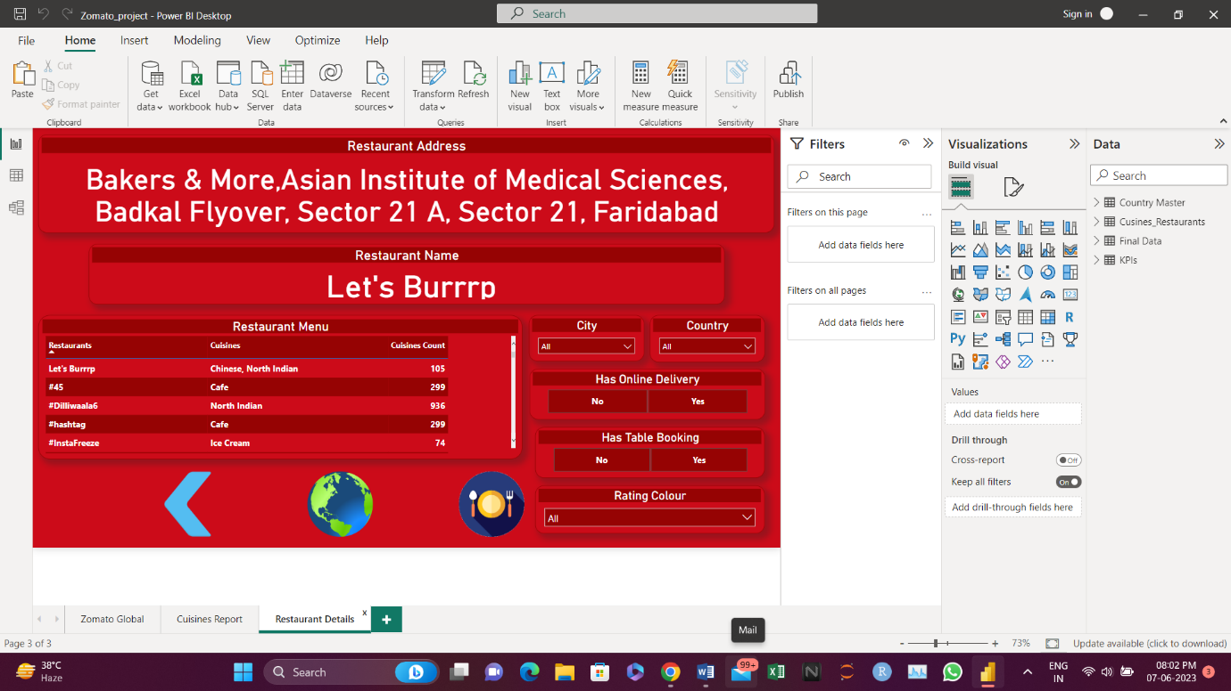Restaurant Details: